Annual Operating Budget Report
2026/2027

This University at Buffalo (UB) Annual Operating Budget Report is a comprehensive presentation of the university’s 2026/2027 budget and investment priorities.


Table of Contents
Strategic Overview 3
1. Executive Summary 3
2. UB Vision and Strategic Goals 3
3. UB as New York State Flagship Institution 4
Operating Budget 5
1. Projected University Operating Budget 5
2. State Support for UB’s Operating Budget: 6
3. Additional State Impact Information 6
Issues and Actions 8
1. Issues and Challenges Affecting UB Budgets 8
2. Actions to Address Fiscal Challenges 12
Budget Planning 14
1. Annual Resource Planning Process (ARPP) 14
2. Financial Capacity 16
3. Investment Requests & Funding 17
Unit Funding and Budget Models 24
1. Base Budget 24
2. Tuition Revenue Budget Models 24
3. Tuition Rate Increase Shares 26
4. Indirect Cost Recovery (ICR) 26
5. Fringe Over Target 26
Fees 26
1. University Fees 26
2. General University Service Fee (GUSF) 27
3. Broad-Based Fees 27
4. Salary Recovery Fee 27
5. Service Center Fees 28
6. Faculty & Staff 28
7. Campus Dining and Campus Living Rates 28
8. Royalty and Patent Income 28
Unit Budgets 29
1. Decanal Units 29
2. Academic Support 30
3. Funding Sources 32
Financial Section 35

Strategic Overview
- Executive Summary
The objective of the UB Annual Operating Budget Report is to provide the University at Buffalo (UB) community with a comprehensive summary of the university’s financial plans for the current fiscal year.
For 2026/27, UB continues to hold a strong financial position. We have significant cash reserves due to forward-looking financial stewardship, long-range planning, and the strength of UB’s enrollment. Additionally, after more than a decade of declining or flat tax support, New York State has for five consecutive years committed additional funding to campuses across the SUNY system including to UB.
- UB Vision and Strategic Goals
Building on the existing strong foundation of academic excellence, knowledge and understanding, UB’s vision is to rank in the nation's top 25 public research universities, thereby expanding the scope of our reach and strengthening our world-wide impact. We will achieve this by accomplishing the following strategic goals:
- Achieve greater societal impact locally and globally by enhancing faculty productivity, research funding and recognition; encouraging innovation and interdisciplinary collaboration; and enhancing research environments and faculty support structures.
- Provide our students with transformative, innovative, and research-grounded educational experiences while elevating students’ academic profile, improving retention and graduation rates, enhancing academic and career support structures, enhancing educational environments, and expanding UB’s leadership in international education.
- Promote a university-wide culture of equity and inclusion by integrating inclusive excellence into all aspects of our university, further enhancing faculty and student diversity, and implementing best practices in recruitment and retention.
- Deepen our engagement in the regional community by continuing to build partnerships in the local community, improving regional health care outcomes, and making Buffalo a destination for health sciences research, education and care.
- UB as New York State Flagship Institution
On January 5, 2022, Governor Kathy Hochul announced the formal designation of the University at Buffalo and Stony Brook University as New York State’s flagship universities. The official recognition of these premier centers of higher education as joint flagships of the State University of New York (SUNY) system reflects the preeminent role that the University at Buffalo (UB) and Stony Brook University (SBU) play statewide, nationally and internationally as models of research and academic excellence. This designation acknowledges the excellence and reputation of our universities, and it will further enhance our ability to continue to recruit the world’s most accomplished faculty and attract outstanding students — regardless of their income or socioeconomic background — and attract even more highly competitive federal research funding.
Across the country, flagship universities are those that provide vital leadership in advancing their home state’s public higher education mission. These universities, most of which, like UB and SBU, are invited members of the Association of American Universities (AAU), are the preeminent centers for research and graduate education in their respective states. They also provide a comprehensive array of professional schools and degree programs and are proven economic catalysts. Flagships attract the world’s best and brightest faculty and students and are nationally and internationally recognized for the quality and impact of their research and academic innovation and rigor.

Operating Budget
- Projected University Operating Budget
- All-funds 2026/2027 budget
Projected $1,088 at billion.
- Tuition revenue
Projected at $376 million or 35% of the overall budget. Tuition revenue represents the largest portion of the university’s operating budget.
- Direct state tax support
Projected at more than $219 million or 20% of the overall budget. Direct state tax support represents the second largest portion of the university’s operating budget and includes a $11.2 million increase over the prior year.
- Fee revenue
Projected at $118 million or 11% of the overall budget. Fee revenue includes the Comprehensive Fee, Academic Excellence Fee, Course Fees, and other student fees.
- Auxiliary revenues
Projected at $101 million or 9% of the overall budget. Auxiliary revenues come primarily from student housing. It also includes athletics, parking, and other rent revenues. This money is collected and spent within collecting units and cannot be used for other purposes.

- State Support for UB’s Operating Budget:
Highlights from New York State’s 2026/2027 budget:
- $54 million in ongoing support for SUNY campuses and statutory colleges
→ UB will receive $11.2 million annually from this new allocation.
Continued Support from Previous Budgets:
- $391 million in ongoing funding from the past three years
→ UB receives $59.3 million annually from these funds.
- $53 million for hiring new full-time faculty across SUNY
→ UB’s share is $12.1 million, with full funding achieved in 2023–2024 after meeting hiring goals.
Why This Matters
These historic investments by NYS into higher education are welcome as UB remains committed to keeping education affordable and accessible. As the university grows with enrollment now exceeding 30,000 students, so do the costs of supporting students with high-quality resources, faculty, and facilities.
UB continues to take strategic steps to manage rising expenses, but the need for ongoing state support and rationale tuition and fee structures remains critical. These efforts ensure UB can maintain excellence and stay competitive with peer institutions nationwide.
- Additional State Impact Information
Over time, UB has become more reliant on tuition revenue as the primary source of funding. As new state funds are committed to UB and enrollments remain relatively flat with increases primarily to non-resident tuition rates, we anticipate that the ratio of state funds to tuition revenue will increase. The chart below (in millions) displays the ratio of state tax support to tuition revenue.
Note: the decrease in 2020/21 revenues is pandemic related; specifically, the state reduced funding by 5%, and tuition revenue decreased significantly due to the decline in international enrollment.

In addition to providing direct state tax support, New York State also covers debt service and fringe benefit cost for UB. The chart below (in millions) shows annual state support trends to UB.

Issues and Actions
- Issues and Challenges Affecting UB Budgets
While UB remains strong financially, the university continues to face several challenges. Among them uncertainty with the current federal research landscape and the impact of how other federal budget cuts may impact New York State’s budget and the potential downstream impact to UB. Additional challenges include decreased international enrollments, unfunded mandates, critical maintenance needs, limited availability of resources, and the evolving role public universities are asked to play in the community and in the lives of its students and faculty who make our work possible.
Contractual Obligations

Personnel
Unfunded negotiated salary increases continue to be the university’s most pressing long-term financial concern. A long-term strategy will need to be reached to address this issue.
- The most recent United University Professions (UUP) contract expired at the end of fiscal year 2026. The newly negotiated contract is for 5 years and includes 4.5% across- the- board salary increase for all members and a 3% or greater increase in the remaining four years. Union members are voting on a newly negotiated contract at the time of publication. Other bargaining units have negotiated similar increases for their members.
- While UB has benefited from state funding in recent years that helped offset the cost of negotiated salary increases, a sustainable long-term strategy for funding future salary increases has yet to be established and implemented.
- Every 1% annual salary increase for employees represents about a $5 million increase in cost to UB annually.
The university supports competitive compensation for its employees, and the university continues to advocate for New York State to fund state-mandated salary increases. Although discussions with the state regarding support for these costs remain ongoing, no additional funding has been committed as of the time of publication. Therefore, units have been advised to assume that salary increases will be unit-funded and to incorporate these costs into their budgets.
Tuition Revenue and Enrollment

Tuition Revenue
State budget approval allowing the SUNY board of trustees to consider applying differential non-resident tuition rates was a critical first step toward aligning UB’s rates with those of our peers. UB’s tuition and fee rates remain low compared to peer public research institutions. While this means great value for UB students and families, it limits resources necessary for the university to fulfill its mission.

Enrollment
The chart below shows UB has maintained strong enrollment. As enrollment grows, this puts pressure on UB’s infrastructure and increases costs for academic support services such as student academic advising, university libraries and student services.

The graph below, normalized using current-year tuition rates across all years to remove the impact of tuition rate increases, illustrates the average tuition revenue per student.
The increase in revenue from Fall 2021 through Fall 2024 reflects a rebound in graduate enrollment, primarily among international students, who were disproportionately affected by the COVID-19 pandemic. In Fall 2025, average tuition revenue per student declined as international graduate enrollment decreased while resident undergraduate enrollment increased.

* Tuition revenue is expressed in 2026/2027 dollars.

Enrollment Growth
Increased headcount can have a widespread effect on the university by increasing demand for campus housing, dining, classroom space, required classes, and more. Units are therefore required to work closely with the provost to implement plans for enrollment growth.
If an academic unit receives additional funding to support enrollment growth, funds are delivered in non-recurring state operating dollars the following year in August.

Considerations for Growing Enrollment
- Overall enrollment growth mix; university tuition revenue
- Impact on campus housing, dining, classroom space, College of Arts and Sciences classes, and UB Curriculum offerings
- Status of the university multi-year financial plan; overall financial health of the university
- Headcount targets for the next fiscal year are discussed in the fall through meetings with academic units led by the Vice Provost for Enrollment Management (EM), in collaboration with the Assistant Vice President for Resource Planning (RP) and the Vice Provost for Institutional Analysis and Planning.
Capital

Academic Space Needs
We were pleased with the capital allotment in this past year’s budget; however, the amount of capital funding does not meet the needs of our aging campus.
UB’s deferred maintenance needs have grown exponentially and have risen above $966 million. Recent investments have led to a sizeable increase in faculty; the need for additional office and research space is also stressing our infrastructure. Continued enrollment growth will be highly dependent upon our ability to expand our physical capacity to accommodate additional students and faculty.
While deferred maintenance needs grow, recent one-time investments have helped as UB will be investing over $1.64 billion in our built environment over the next decade, embarking on one of the most significant periods of campus growth and modernization in UB’s history.
Learn more about UB’s capital projects

Holistic Capital Planning
Expectations surrounding UB’s ability to address capital issues in a comprehensive manner also remain an area of concern.
Though the university is pursuing efficiency measures to defray these costs, without consistent and adequate funding that is in alignment with our deferred maintenance needs, academic quality, faculty recruitment and retention, and the student experience will be negatively impacted.
While the university continues to support efforts to diversify and grow our student body while also providing a safe and inclusive campus, these efforts also come at with added cost.
We consider these costs to be a sound investment in our future and the future of our students, however, resources allocated to these initiatives require shifting resources away from other areas of investment.

Research Support Costs
We remain committed to growing our research enterprise and advancing scholarly excellence. We view these costs as an investment in the university’s future and continue to dedicate resources to supporting research activities. While UB achieved another record year for research expenditures in 2023–24, budget reductions at several federal agencies—among the university’s largest sources of research funding—have created challenges in sustaining this trajectory. The university will continue to closely monitor the evolving federal funding landscape and respond strategically to mitigate risks and capitalize on emerging opportunities.
Related to our investments in research, the graph below represents UB’s research expenditures in millions.

- Actions to Address Fiscal Challenges
To address and prepare for fiscal challenges, we evaluate operations to identify efficiencies, maximize our current resources, review and adjust our financial projections, and advocate for addition support from the State. Our Annual Resource Planning Process (ARPP) continuously evolves to ensure resources are allocated in a manner that aligns with university priorities.
Below is an overview of some of the steps we have taken to maintain our fiscal strength and prepare for inevitable change, challenge, and opportunity.
- In 2021/22, we revised the academic-year budget model. Now with SUNY revising their Pooled Off-Set overhead charge policy, it allows us to streamline the summer and winter models in 2025/26. These model updates provide additional funding to academic units that grow their revenue. Conversely, for units with declining revenue, we are able to quickly adjust revenue to those units and chart a path for future success. The models are outlined later in this document.
- In 2024, we implemented UPlan, a budgeting, planning and forecasting system that improves accuracy and efficiency and supports scenario planning. UPlan integrated budget development for workforce, commitment management, revenue and non-personal operating budgets in one platform.
- Our data analytics function provides both central administration and units with department and program-level data. This data is integrated with UPlan and is used to forecast enrollment, tuition, and for resource planning.
- We implemented multi-year utilities planning to achieve energy savings.
- We developed a multi-phased approach to achieve our Capital Master Plan aspirations.

Technology & Business Process Solutions
UB has embraced a number of technological and business process solutions to reduce costs and better manage our resources, as part of our university-wide Operational Excellence initiative.
Learn more about UB’s Operational Excellence initiative
State-controlled dependencies
The university continues to advocate for state support and tuition and fee rates that, together, keep UB’s resources on par with peer institutions.
Capital funding will remain a priority during this year’s budget. Capital funding advocacy must include funds for critical maintenance and strategic priority projects including major building renovations and new buildings.
UB is experiencing an increase in demand for STEM programs. STEM programs require modern laboratories and facilities. Access to campus space for both classroom and laboratories is strained.

Budget Planning
- Annual Resource Planning Process (ARPP)
The Annual Resource Planning Process (ARPP) provides a framework for the university to review our financial capacity, align our current resources to support our priorities, and assess potential areas for new investment.
During our Annual Resource Planning Process (ARPP), we make collaborative and thoughtful decisions about the degree to which a program helps us achieve our strategic goals. We consider how it serves our students’ changing needs. How it supports our neighboring communities. How it supports our faculty’s groundbreaking research. And how far it can get us toward our next goal: being recognized among the top 25 public research universities in the U.S.
Each funding request herein is critically reviewed and, combined with our ongoing programs to find efficiencies and other cost-savings, will allow UB to continue to make valuable contributions locally, nationally, and globally.
Guiding Principles
UB utilizes the ARPP to plan for its financial needs. Guided by five principles, our planning process takes a holistic approach to identifying university needs and allocating available funds to support both individual unit needs and the strategic priorities of the university a whole.
- Strategic - The plan aligns incentives with our mission and strategic behaviors.
- Predictable - The plan builds models that provide a reliable foundation for planning.
- Flexibility - The plan builds models that anticipate and are responsive to changes in the economic environment as well as incorporating appropriate risk management strategies.
- Integration - The plan considers the university as a whole and make intentional connections between organizational needs and priorities.
- Stewardship - The plan exercises prudence in managing university resources, diversifies revenue streams to promote resilience, maintains appropriate reserves and rewards efficiency and effectiveness.
Tightly woven into our ARPP are UB’s four strategic goals that will help us achieve our vision of advancing into the nation's top 25 public research universities.
Collaborative Approach
During the ARPP, UB’s Provost and the Division of Finance and Administration collaborate closely with units to plan for future years. The process encompasses the review of many different factors including enrollment, tuition revenue, staffing, research expenditures and proposals, endowments, unit spending plans, capital/space, risks and contingencies, and investment proposals. The budget planning process looks at funding priorities through these lenses:
- Comprehensive asset/liability management
- Integrated, single-institutional point of view
- Long-term in nature
- Analyze returns on investments!
- Proactive
- Dynamic and scenario-based
- Transparency
Also, during the ARPP, the Division of Finance and Administration’s Resource Planning team collaborates with UB’s Division of Student Life to set student fees for specific services and ensure that the university is accommodating their needs. The outcomes of the ARPP are submitted to SUNY for approval before implementation.
Planning Phases
The ARPP consists of three phases:
- Phase 1 (September – January): Three-Year Plan information collection through UPlan
- Key Outcome: Communicate guidance to VP/Deans and unit business officers based on the university’s financial position to assist units in providing their input and needs through the Three-Year Plan workbook.
- Phase 2 (January-March): Analysis, Discussion & Decision-Making
- Key Outcome: VP/Deans present the unit’s position to senior leadership to gain a shared understanding of needs and to inform resource planning decisions.
- Phase 3 (March-July): Closure of Annual Resource Planning Process
- Key Outcome: Communicate unit expectations and outcomes to VP/Deans to finalize Three-Year Plans and implement resource planning decisions.
The Division of Finance and Administration loads new fiscal year budgets into the financial system for July 1 implementation.
- Financial Capacity
UB’s financial health is a result of thoughtful planning and committed financial stewardship. It is this foundation that allows us to maintain a long-term strategic plan and to manage through periods of volatility. For 2026/27, some important factors influenced our beginning fund balances:
- Our five-year rolling financial planning process anticipates and considers major economic opportunities and challenges.
- Our multi-year planning effort for addressing unfunded negotiated salary increases means that decanal and divisional units have plans to absorb these costs in the short term.
- We continue to maintain contingency reserves which helps create confidence that we can maintain our strategic focus and meet our long-term goals.

The graph below represents projected centrally managed Internal Financial Plan (IFP) balances in millions over the next five years. Beginning IFP balances are strategic reserves set aside to fund investments committed through the ARPP.
The graph excludes the university’s $40 million emergency reserve intended to manage unforeseen events and can only be used if the President, Provost, and Vice President for Finance & Administration agree it is necessary.

The overall decline in the first two years reflects commitments made during the 2026/27 ARPP as well as ongoing investments from prior ARPP cycles. Balance begin to grow beyond three year as the number of existing commitments decrease. In addition to investments made this scenario also makes the following major assumptions:
- Tuition revenue increases back to 2024/25 levels with increases to non-resident tuition rates and continued growth of resident undergraduate enrollment, while international enrollment continues to decline.
- Indirect revenue drops by approximately $5M in 2026/27 with modest growth in the out years.
- Other major revenue sources remain relatively flat
This modeling helps to illustrate a likely potential scenario UB may face as it relates to some major sources of revenue in the short-term but is just one of many planning scenarios utilized to help inform decisions to best align with strategic priorities and financial capacity throughout the ARPP cycle.
- Investment Requests & Funding
As an outcome of the 2026/2027 ARPP, commitments of $255 million over three years were made to support a variety of university initiatives. These commitments include $37M in recurring funds and $143M in non-recurring funds. The recurring amount is added for each of the three years for a three-year total of $255 million.
The graph below provides a breakdown of all commitments made during the 2026/2027 ARPP by priority.
Investment Priorities

Building Exceptional Academic Programs
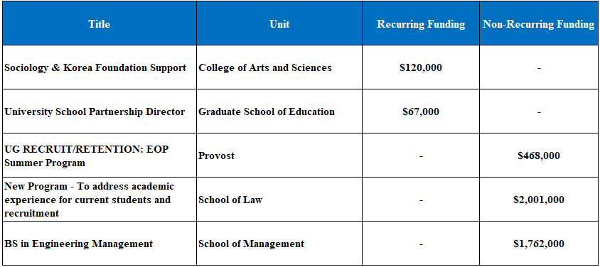

Enhancing the Campus Environment
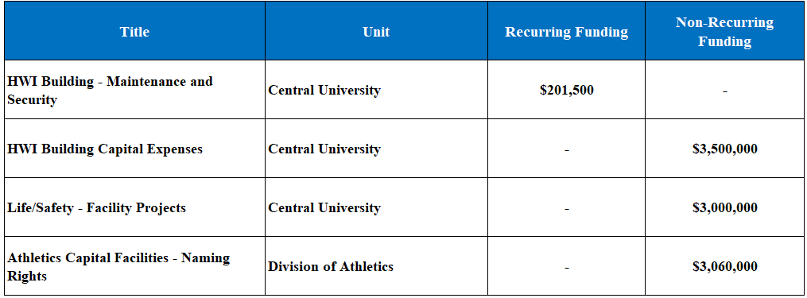

Growing Faculty, Research and Recognition
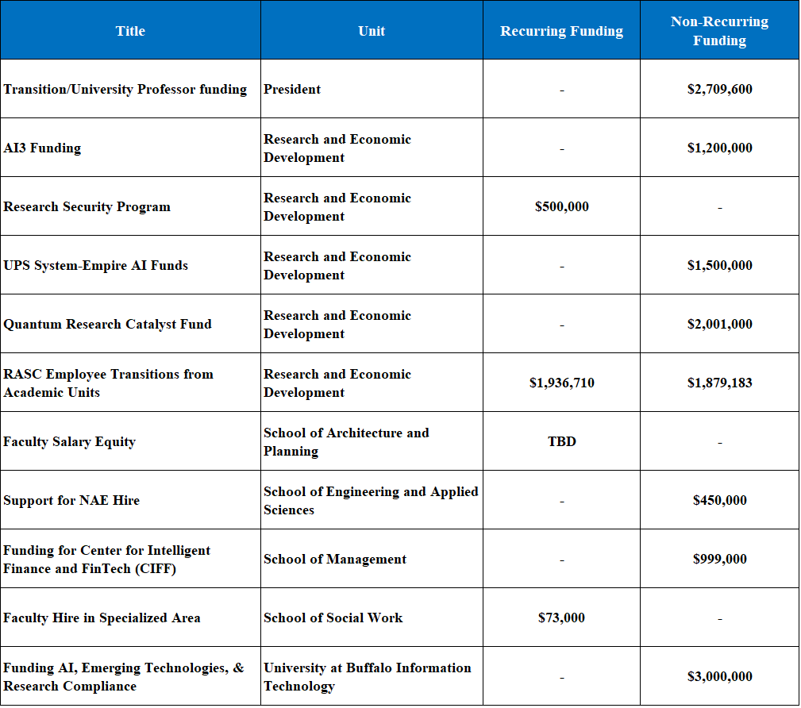

Providing Budget Support
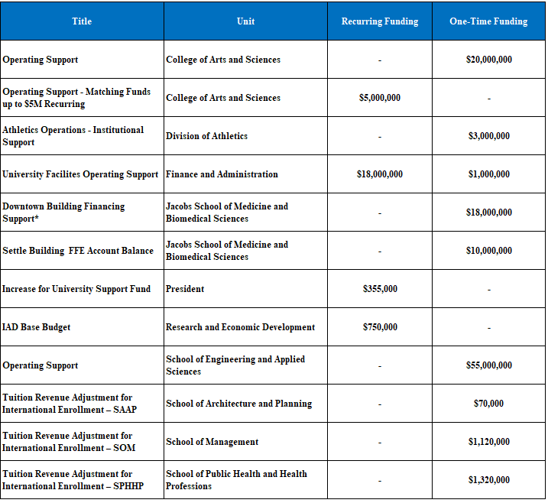

Providing Strong Academic and Student Support

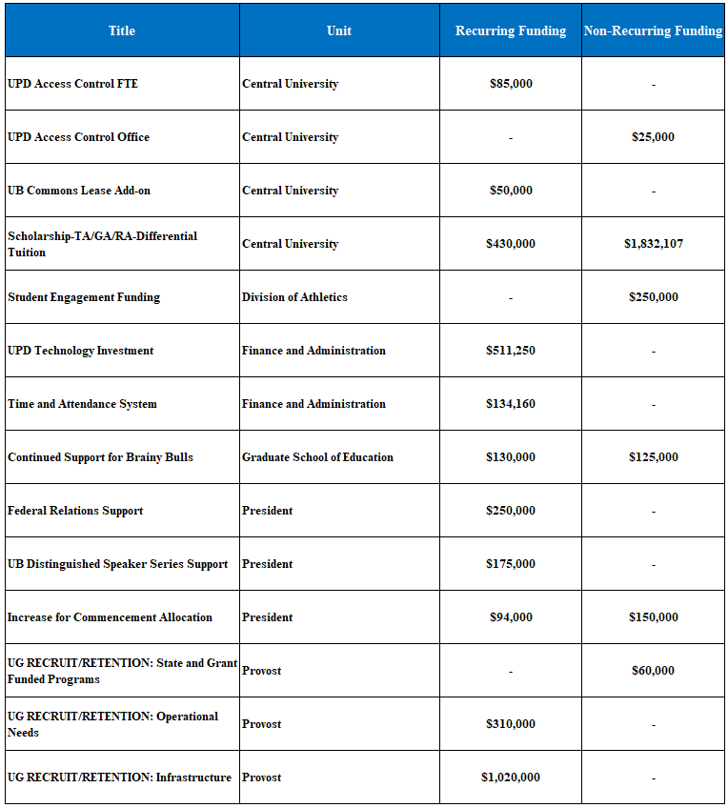

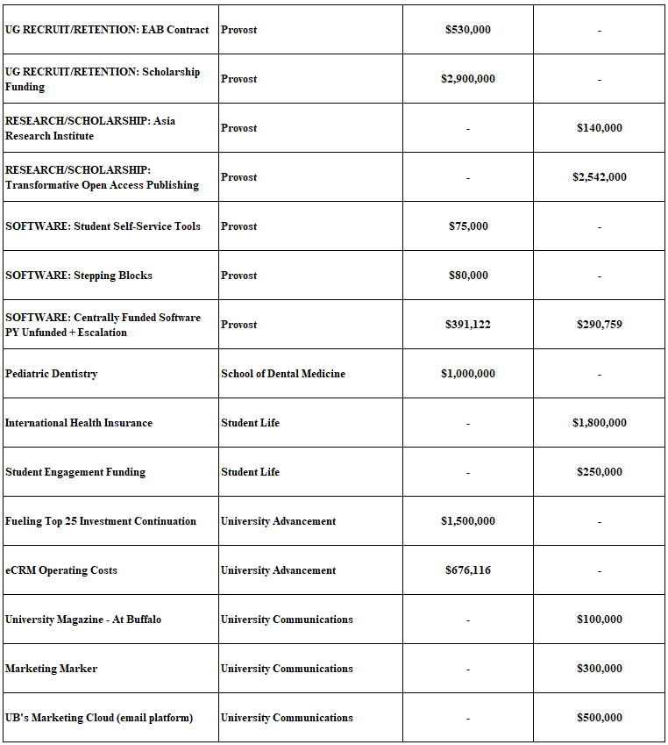

Unit Funding and Budget Models
- Base Budget
A unit’s base budget comprises the following:
- a combination of historical agreements between current and former Provosts and Deans.
- tuition revenue to support base enrollment.
- shares from tuition increases.
- investments to support unit and university special initiatives.
Base budgets are delivered on or about July 1.
- Tuition Revenue Budget Models
- Academic-Year Budget Model
The budget model aligns unit tuition revenue targets with recent enrollment trends, distributes revenue to growing units, and calculates targets for all units in a consistent manner.
Targets are reset annually based on a weighted three-year rolling average of tuition revenue generated by the unit.
- 50% weight for the most recent year
- 30% weight for the next year
- 20% weight for the third year
Unit targets are expressed as a single value; however, they are calculated by combining separate undergraduate and graduate/professional targets. This approach helps neutralize the impact of undergraduate international student enrollment, which is not directly controlled by individual schools.
- Grad/Professional (G/P) – uses gross tuition revenue as a metric to calculate G/P targets.
- Undergraduate (UG) – uses university-wide UG credit hour average values and unit UG credit hours to calculate UG targets.
If a unit exceeds its tuition revenue target in a given year, the unit will receive 70% of the performance above target in non-recurring state operating funds in the following year. Units that do not meet their target in a given year are subject to the Tuition Revenue Shortfall Assessment (TRSA) outlined below.

Tuition Revenue Shortfall Adjustment (TRSA)
Band* | TRSA %
>2% | 0%
2% to >5% | 40%
5% to >10% | 60%
10% | 80%
*Bands: The purpose of the bands is to recognize that a unit may be unable to anticipate enrollment fluctuations (in which case the risk is shared between the unit and the university), as well as the opportunity for a unit to make short-term adjustments to lessen the impact of unanticipated enrollment shortfalls.
Base budgets are adjusted at the beginning of the fiscal year in alignment with updated tuition revenue target. The change to base budget is 70% of the change to the tuition revenue target.
- Summer Session Budget Model
Units do not have summer tuition revenue targets. Tuition revenue is shared 60% to units and 40% to central for investment.
The costs of offering summer session courses are expected by SUNY to be funded from tuition revenues earned in those courses or from other institutional revenues.
- Winter Session Budget Model
Units do not have winter tuition revenue targets. Tuition revenue is shared 70% to units and 30% to central for investment.
The costs of offering winter session courses are expected by SUNY to be funded from tuition revenues earned in those courses or from other institutional revenues.
- Tuition Rate Increase Shares
Academic units receive a recurring increase to base budget equal to 50% of the increase in graduate and professional tuition rates.
- Indirect Cost Recovery (ICR)
Each year, a percentage of indirect costs recovered from sponsored projects is distributed to university entities based upon the affiliation and relative contributions of key personnel to project objectives. At the discretion of the Provost, ICR distribution may occur to other (non-academic) university entities. The current ICR distribution rate is 12%. Delivery of the 12% ICR distribution for the prior year occurs in August.
Learn more about Indirect (F&A) Cost Recovery and Distribution policy
- Fringe Over Target
The university has a fixed fringe cost target. Any amount incurred over the target is reimbursed 100% by SUNY.
Units have a fixed fringe cost target. Any amount incurred over the target is reimbursed 100% by the university.

Fees
- University Fees
University Fees represent all non-service center fees on campus. There are three distinct categories based on level of approval required.
- SUNY Board of Trustee Approved Fees - University-wide fees paid by students as a condition of attendance. Examples include comprehensive fee, admission deposits, etc.
- SUNY Chancellor Approved Fees - Mandatory student fees with set amounts assessed by all campuses due to a student's action or inaction, campus-specific fees for special services or campus-specific user fees. Examples include undergraduate application fees, music instrument rental, library fees and fines, etc.
- Campus Approved Fees - Customer fees for services. Examples include non-credit bearing course fees, residence hall charges, etc.
Learn more about University Fees
- General University Service Fee (GUSF)
GUSF of 13% remains in effect and is charged on external revenue deposited into Income Fund Reimbursable (IFR), University at Buffalo Foundation (UBF), Research Foundation (RF), or Faculty Student Association (Campus Dining and Shops) accounts as outlined in the Disclosure of All Funds Policy.
Learn more about General University Service Fee (GUSF)
- Broad-Based Fees
Broad-based fees are generally charged to all enrolled students to finance discrete activities that benefit the student body, excluding those activities that are part of the core instructional program. During the ARPP, units have the opportunity to share five-year fee requests as well as information on the planned utilization of funds between mandates and strategic investments. The information provided will be considered during the preparation of the university’s final request to SUNY for Broad-Based Fee rate increases.
Learn more about Broad Based Fees
Higher Education Price Index (HEPI)
The current fee policies state that “Annual Broad-Based Fee increases should be no greater than the Higher Education Price Index (HEPI) unless there is a compelling case.” For 2026/2027, assume the maximum annual broad-based fee weighted average HEPI percentage to be 3.8%.
Learn more about Higher Education Price Index (HEPI)
- Salary Recovery Fee
The Salary Recovery Fee is a flat fee, charged at a rate of 20% on Salary Recovery funds deposited into Income Fund Reimbursable (IFR) accounts. These funds help to preserve research infrastructures, services, and faculty compensation. Salary recovery funds are considered core state support reimbursing the state for faculty member time spent conducting research.
Learn more about the Salary Recovery Fee
- Service Center Fees
Service centers provide services that support the internal operations of the university or can provide services to external users. Service center fees recover the cost of operations of the service center.
Learn more about Service Center Fees
Learn more about Financial Management of Service Centers Policy
- Faculty & Staff
Fringe Benefits Rates
Fringe benefits are part of a regular employee's remuneration package that is not pay (expressed as a percentage), which may or may not be charged directly to an account. This includes payroll taxes, health insurance, retirement and other benefits. For State Operating accounts, these benefits are paid directly through the office of the State Controller and are not charged to campus accounts.
Learn more about Fringe Rates
- Campus Dining and Campus Living Rates
Campus dining rates and campus housing rates are evaluated on an annual basis and may be subject to adjustments. Senior leadership works with the Vice President for Student Life to review these rates amongst a student’s total cost of attendance.
Learn more about campus meal plans and campus housing costs
- Royalty and Patent Income
Central university funding for Royalty and Patent Income is part of the university Internal Financial Plan and is committed based on the recommendation and approval of the Provost, Vice President of Finance and Administration and President as part of the AARP.

Unit Budgets
- Decanal Units
(in millions)
 | Sources | % of Total | Uses | % of Total
College of Arts and Sciences | $148.1 | 13.6% | $140.8 | 13.1%
Graduate School of Education | $20.8 | 1.9% | $22.9 | 2.1%
Jacobs School of Medicine and Biomedical Sciences | $152.7 | 14.0% | $150.7 | 14.0%
School of Architecture and Planning | $11.2 | 1.0% | $12.9 | 1.2%
School of Dental Medicine | $47.1 | 4.3% | $50.0 | 4.7%
School of Engineering and Applied Sciences | $84.2 | 7.7% | $85.6 | 8.0%
School of Law | $20.5 | 1.9% | $20.9 | 1.9%
School of Management | $37.1 | 3.4% | $40.1 | 3.7%
School of Nursing | $14.0 | 1.3% | $13.2 | 1.2%
School of Pharmacy and Pharmaceutical Sciences | $20.3 | 1.9% | $20.3 | 1.9%
School of Public Health and Health Professions | $23.1 | 2.1% | $26.7 | 2.5%
School of Social Work | $10.8 | 1.0% | $11.2 | 1.0%
Decanal Units | $589.8 | 54.3% | $595.3 | 55.4%
In the 2026/27 academic year, budgeted uses exceed sources by $5.5M across 12 academic units. Unit carryforward balances will be used to cover overages.

- Academic Support
(in millions)
 | Sources | % of Total | Uses | % of Total
University at Buffalo Information Technology | $45.6 | 4.2% | $58.5 | 5.4%
Division of Athletics | $43.1 | 4.0% | $48.9 | 4.6%
Finance and Administration | $131.4 | 12.1% | $115.9 | 10.8%
Health Sciences | $3.4 | 0.3% | $4.5 | 0.4%
President | $10.1 | 0.9% | $8.9 | 0.8%
Provost | $69.5 | 6.4% | $74.4 | 6.9%
Research and Economic Development | $47.4 | 4.4% | $40.1 | 3.7%
Student Life | $122.0 | 11.2% | $102.3 | 9.5%
University Advancement | $18.5 | 1.7% | $18.8 | 1.7%
University Communications | $5.9 | 0.5% | $6.5 | 0.6%
Academic Support | $497.0 | 45.7% | $478.9 | 44.6%
In the 2026/27 academic year, budgeted sources exceed uses by $18.1 million across 10 academic support units. Unit carryforward balances are currently covering overages in 2025/26.
- Academic support units are necessary for the academic and research mission of the university. Some of the revenue is generated directly by these units and restricted to their use.

 | Sources | % of Total | Uses | % of Total
Campus Financial Plan/Central University | $37.2 | 3.4% | $108.6 | 10.1%
Campus Financial Plan/Central University | $37.2 | 3.4% | $108.6 | 10.1%
Campus Financial Plan includes funding available for investment through the ARPP. Central University includes funding for centrally managed areas including but not limited to the Merit Scholarship, University Utilities, and centrally managed Instructional Facilities budgets. Overages in 2026/27 are a planned spend down of university strategic reserves.

Academic support units include the following areas:
University at Buffalo Information Technology. Includes Enterprise Application Services; Information Technology (IT) Customer Services; Network & Communication Services; and other IT support.
Division of Athletics. Includes UB’s 16 Division I sports; various administrative and student athlete support areas; and Recreation and Intramurals.
Finance and Administration. Includes the Office of Finance & Administration; Business Services; Emergency Management; Human Resources; Parking & Transportation Services; Resource Planning; Sustainability; University Police; and University Facilities.
Health Sciences. Includes VP for Health Sciences and office of Interprofessional Education.
President. Includes the office of the President; Equity, Internal Audit, Diversity & Inclusion; Government & Community Relations; and University Events.
Provost. Includes office of the Provost; Academic Planning; Enrollment Management; Faculty Affairs; Inclusive Excellence; Institutional Analysis; International Education; Educational Affairs; Educational Opportunity Center; University Libraries; and University Shared Governance.
Research & Economic Development. Includes Sponsored Research Administration; Communities of Excellence; Research Advancement; Economic Development; Animal Facilities; Research Compliance; and several centers and institutes.
Student Life. Includes Student Health & Wellness; Counseling Services; Dean of Students; and Campus Living.
University Advancement. Includes advancement teams for all academic units; Alumni Engagement; Philanthropy.
University Communications. Includes University Communications; Trademarks and Licensing; and university branding initiatives.

- Funding Sources
The tables below note the common sources of funding to campus budgets and how those funds are used. Each unit is required to align their costs to the appropriate sources.
State Funds

Sources of Funds
State Tax | Tuition Revenue | Income Fund Reimbursable (IFR) | State Univ. Tuition Reimbursable (SUTRA) | Dorm Income Fund Reimbursable (DIFR) | Research Foundation (RF) | UB Foundation (UBF)
Appropriated by NYS Govt.  Allocated to campus by SUNY | Student tuition payments | Student fee revenue  External funds self-supporting programs | Students in Study Abroad, contract courses, etc. | Residence Hall rent revenue | Federal, state, private grants  Indirect cost recovery earnings | Donor support  On-campus apartment rent  Clinic and other self-supporting program revenues

Uses of Funds
 | State  Tax | Tuition  Revenue | IFR | SUTRA | DIFR | RF | UBF
Instructional Salary Expenses | X | X | X | X
Non-Instructional Salary Expenses / Salary associated with fee revenue | X | X | X | X | X | X | X
Temporary Service Expense | X | X | X | X | X | X | X
Fringe Benefit Expense | NA | NA | 40% on salary expenses | NA | 40% on salary expenses | Applicable fringe rate per appointment type | Actual fringe cost
Non-Salary Expense (e.g., contractual services, supplies, travel, prof fees, equipment) | X | X | X | X | X | X | X

State Operating
State Operating accounts are funded from state tax dollars and campus revenues from tuition and certain other sources. Units receive a state operating allocation as part of their base budget. Changes to unit state budget allocations are commonly the result of budget model implementation and strategic investments awarded through the annual resource planning process.
Income Fund Reimbursable (IFR)
IFR accounts are self-supporting accounts that track cash collections and matching expenditures associated with educational and related activities provided to students and other customers. An IFR account differs from a State Operating account in that it is supported by cash receipts. The source of the revenue determines whether the General University Service Fee will be assessed. The primary sources of revenue for IFR accounts include:
- Salary recovery (payment from Research Foundation grants for the salary and fringe benefits of individuals on the state payroll who work on sponsored programs)
- Fees, fines, deposits and rentals (course fees, parking, photocopying, rental of campus facilities, library fines, etc.)
- State grants and awards
- Continuing education programs.
State University Tuition Reimbursable (SUTRA)
State University Tuition Reimbursable Accounts funding is generated from self-supporting overseas programs, contract courses, summer and winter session tuition. Units receive summer session base budget and tuition revenue share via commitments solidified through the ARPP process. SUTRA accounts operate similar to Income Fund Reimbursable (IFR) accounts.

Dormitory Income Fund Reimbursable (DIFR)
Dormitory Income Fund Reimbursable is a group of accounts that are self-supporting and used to administer residence hall room rental fees and charges. DIFR accounts operate similar to IFR accounts.

Research Foundation (RF)
Research Foundation accounts record research, instruction, training and economic development activities conducted under the direction of university faculty and staff and funded by organizations both external and internal to the university. There are two distinct types of RF accounts: Sponsored accounts and Non-Sponsored accounts.
Sponsored accounts are funded by sponsors external to the university and are used for programs of research, scholarly and creative activities, education and training, and public service.
Non-sponsored accounts are funded by indirect cost dollars. The university receives Indirect Cost funds as reimbursement for overhead costs associated with sponsored research. Indirect Costs, also known as Facilities and Administrative (F&A) costs or overhead costs, are real costs related to sponsored projects that are not easily attributable to individual projects. Examples include maintenance, security, heating, cooling, lighting, space, disposal of hazardous waste, secretarial support, the library, and cost of compliance with government regulations.
UB recovers the total direct costs and indirect (facilities and administrative (F&A)) costs for each sponsored award unless specifically prohibited or limited by the funding agency. Because indirect (F&A) costs cannot be readily assigned to a particular sponsored project or activity, they must be recovered from funding agencies through the application of the federally approved indirect (F&A) cost rates. When allowed by the sponsor, all proposals for external funding must include a budget request for indirect (F&A) costs using the appropriate federal rate.
Royalty Income*: Royalty income is realized from the commercialization of UB intellectual property. When UB intellectual property is licensed and generates royalty for UB, that royalty is shared with those who made the innovation, in accordance with the Royalty Distribution Policy. After paying the inventors’ share of royalty income, the remaining portion is shared across departments and schools of the inventors, as well as with the university. The department, school and university share of Research Foundation non-sponsored funds must be used to support scientific research or education.
*All royalty income designated to a campus allocated account MUST be utilized for the support of scientific research or education per the Bayh-Dole Act which governs intellectual property arising from federal government-funded research. Since the majority (if not all) of UB intellectual property (IP) arises from federal-funded research, all intellectual property is managed by Bayh-Dole Act.
Learn more about the Bayh-Dole Act
Patent Income: Patent reimbursement funds support the UB Technology Transfer Office (TT), through the Vice President of Research and Economic Development (VPRED) in the Internal Financial Plan and recouped by the university through patent reimbursements.

UB Foundation (UBF)
Funds managed by UBF support and promote UB activities and programs. UBF accounts are funded primarily from gifts, endowed funds, grants and fee revenues.
Learn more about UB Foundation funding sources

Financial Section
Each year, UB provides an Overview of Financial Activities that is designed to provide UB’s leadership with a comprehensive, high-level summary of financial information campus to assist with decision making.
- UB Financial Statements. Annual financial statements for the fiscal year ending June 30. These unaudited financial statements are compiled based on State University of New York (SUNY) campus-level financial reports representing the operations for state and research foundation activities.
- Audited financial statements for UB are included in the appendix to the Overview of Financial Activities.
- Supplemental Financial Activity Reporting. Additional financial information including an overview of core operating activities and other key financial highlights.
View the current version of UB's Financial Reporting

